**RAC Team Communications Activity Sheet**

* Please either print this and fill it out by hand or download it and type in your answers, then print it.
* **Bring this worksheet (on paper) to your RAC Workshop! We will discuss it there**.

**Part 1.**   
  
What are 2-3 examples of situations in warning operations where effective communication in your office is critical?



What pieces of information are critical to communicate among your team during warning operations? Try to list 4 to 6 things.



**Part 2.**

|  |  |
| --- | --- |
| What are some barriers you can think of to effective communication during warning operations? (Try to list 3-5 barriers.) | For each barrier you listed, think of a way you can solve or overcome them. (Truly stumped? Note that here and see if discussing with peers can help.) |
| 1. |  |
| 2. |  |
| 3. |  |
| 4. |  |
| 5. |  |

**Part 3.**  
List 3 communication challenges in your office that are in your sphere of control or influence that you can work on at RAC and/or at your office.



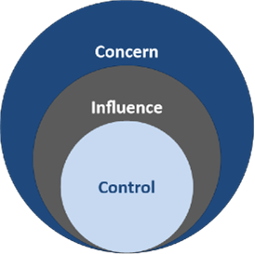

**Notes (from videos or other notes to self)**