AWIPS Build 18.1.1 NWPS Release and Post Install Notes
AWIPS Build 18.1.1 Post Install: WCOSS Runs Status Notification Scripts

Addendum to the Latest 16.4.1 and 17.3.1 Post Release Notes

NOTE FOR 18.1.1 SITES: If you have any local overrides of the files being updated below with this baseline, you will need to check them closely before assuming the baseline is not working. Either use add ons or merge the new baseline with any site overrides.

If you are a test site for this, you should read this whole doc. Whether you are a test site or not, If you want to start ingesting the Rip Current Probabilities that will be available to you post 17.3.1, then you need to at the very least read this.

With Build 18.1.1 we are introducing changes to support the following:

- Rip Current probabilities are now ingested under their own grib2 variable name in AWIPS.
- Dune Erosion and Overwash probabilities were added to the system.
- Grib2 tables updated to support these 3 new parameters.
- A procedure was baselined that will allow you to populate these elements in GFE.
- With build 17.3.1 the system was modified to support NWPS runs going out to 144 hours. However, the Run_NWPS GUI was not modified to reflect that despite the fact the system will run anyway out to 144 hours at WCOSS. The run length option in the GUI is only used by those that are part of development efforts and still run the model locally (just a couple at this point). With this build this has been fixed in the Run_NWPS procedure. Also the procedure has been modified to check your inventory goes out far enough to support the new 144 hours long simulations at WCOSS. If the check fails, the procedure stops and notifies the forecaster. Other options were also removed from the Run_NWPS GUI in 18.1.1 as they are not used with the WCOSS runs.
- The baseline Period parameter definition in serverConfig was modified to go up to 30 seconds.
- WCOSS Runs Status Notification Scripts are being made available to help you automate notification of WCOSS Run Status.

Here are the files and changes that are being checked into the system to enable this. All files referenced here are found in this tar file. If you are a site testing this out prior to baseline, you can do so by repeating all these steps at the site level.

1.) Grib2 Table instructions - The following grib2 tables in server side need to be updated with the ones inside the tables directory in the tar package (if you are testing this at site level, you can make the additions in the tables in the table dir of the tar package through your localization EDEX->Grib->tables menu perspective. Copy the base to site and make the additions):

/awips2/edex/data/utility/common_static/base/grib/tables/-1/-1/4.2.10.1.table
/awips2/edex/data/utility/common_static/base/grib/tables/7/0/4.2.10.3.table
/awips2/edex/data/utility/common_static/base/grib/tables/7/10/4.2.10.3.table
/awips2/edex/data/utility/common_static/base/grib/tables/7/2/4.2.10.3.table
/awips2/edex/data/utility/common_static/base/grib/tables/7/7/4.2.10.3.table
/awips2/edex/data/utility/common_static/base/grib/tables/7/8/4.2.10.3.table
/awips2/edex/data/utility/common_static/base/grib/tables/9/0/4.2.10.1.table

This is consistent with the following tables updated in the grib2 site:

http://www.nco.ncep.noaa.gov/pmb/docs/grib2/grib2_table4-2-10-1.shtml
http://www.nco.ncep.noaa.gov/pmb/docs/grib2/grib2_table4-2-10-3.shtml

2.) The CopyRipRunupProbs.py and updated Run_NWPS.py procedures need to be baselined under the follow dir on client side:

/awips2/cave/etc/gfe/userPython/procedures

This CopyRipRunupProbs.py procedure copies the RipProb, ErosionProb, and OverwashProb elements from nwpsCG1XXX D2D db to the Fcst db.

If site testing prior to baseline it try it out at site level.

The Run_NWPS.py GUI was updated to hide options that are not used by WCOSS as described above for the most part and clean it up a bit. Here is the new GUI:

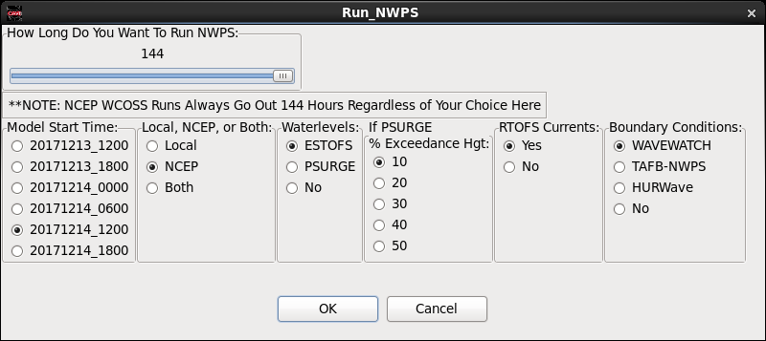

If you are using a SITE level version to change some of the default parameters, merge your overrides with new latest version. Whatever you do, DO NOT get rid of variables stored by the GUI into the inp_args variable that gets dumped into the control file sent to WCOSS. If you do your WCOSS runs will fail.

3.) To get access to Overwash and Erosion probabilities in the Volume Browser, the following entries were added to the following files on the client side:

Also, updated Rip Current Probability for new key.

(if you are testing this at site level, you can make the additions from the applicable files in the tar package through your localization D2D->Volume Browser Menus->fields->planview_timeseries->sfc2d menu perspective. Copy the base to site and make the additions)

/awips2/cave/etc/menus/volumebrowser/fields/planview-timeseries/sfc2d/marine.xml
/awips2/cave/etc/menus/volumebrowser/fields/planview-timeseries/sfc2d/NWPS.xml

<contribute xsi:type=”menuItem” menuText=”Dune Erosion Probability” key=”EROSNP
” indentText=”false” />

<contribute xsi:type=”menuItem” menuText=”Dune Overwash Probability” key=”OWASHP
” indentText=”false” />

<contribute xsi:type=”menuItem” menuText=”Rip Current Probability” key=”RIPCOP
” indentText=”false” />

/awips2/edex/data/utility/common_static/base/styleRules/gridImageryStyleRules.xml - In the file being checked in there are 36 creatingEntity entered, one for each coastal baseline nwpsCG1XXX domain file. With 18.1.1 the existing entry for Rip Current Probability was updated for the new key (RIPCOP) and two new entries were added for Dune Erosion and Overwash probabilities (Note: The gridImageryStyleRules file submitted is based on the baseline in my system which is from a 17.1.4 system. In truth the additions below need to be merged with the latest 18.1.1 version of this file):

(if you are testing this at site level, you can make the additions from the applicable files in the tar package through your localization CAVE->Style Rules menu perspective. Copy the base to site and make the additions)

<styleRule>
<paramLevelMatches>
<parameter>RIPCOP</parameter>
<creatingEntity>nwpsCG1XXX</creatingEntity>
</paramLevelMatches>
<imageStyle>
<interpolate>false</interpolate>
<displayUnits>%</displayUnits>
<range scale="LINEAR">
<minValue>0</minValue>
<maxValue>100</maxValue>
</range>
<defaultColormap>GFE/RipProb</defaultColormap>
<colorbarLabeling>
<values>0 25 50 100</values>
</colorbarLabeling>
</imageStyle>
</styleRule>

- Add new rules for Dune Overwash and Erosion with a baseline colormap

<styleRule>
<paramLevelMatches>
<parameter>EROSNP</parameter>
<creatingEntity>nwpsCG1XXX</creatingEntity>
</paramLevelMatches>
<imageStyle>
<interpolate>false</interpolate>
<displayUnits>%</displayUnits>
<range scale="LINEAR">
<minValue>0</minValue>
<maxValue>100</maxValue>
</range>
<defaultColormap>GFE/RunupProbs</defaultColormap>
<colorbarLabeling>
<values>0 25 50 75 100</values>
</colorbarLabeling>
</imageStyle>
</styleRule>

<styleRule>
<paramLevelMatches>
<parameter>OWASHP</parameter>
<creatingEntity>nwpsCG1XXX</creatingEntity>
</paramLevelMatches>
<imageStyle>
<interpolate>false</interpolate>
<displayUnits>%</displayUnits>
<range scale="LINEAR">
<minValue>0</minValue>
<maxValue>100</maxValue>
</range>
<defaultColormap>GFE/RunupProbs</defaultColormap>
<colorbarLabeling>
<values>0 25 50 75 100</values>
</colorbarLabeling>
</imageStyle>
</styleRule>

The following baseline color curve was added in support of the Dune Erosion/Overwash Probabilities in both D2D and GFE:

/awips2/edex/data/utility/common_static/base/colormaps/GFE/RunupProbs.cmap

4.) On the GFE side, a few files were updated:

/awips2/edex/data/utility/common_static/base/grid/parameterInfo/nwpsCG1.xml

- Updated RipProb element for latest parameter naming convention
- Added Dune Erosion and Dune Overwash elements.

(if you are testing this at site level, you can make the additions from the applicable files in the tar package through your localization GFE Server->Parameter Info Files menu perspective. Copy the base to site and make the additions)

<!-- RIPCOP: Rip Current Probability -->
<gridParameterInfo xmlns:xsi="http://www.w3.org/2001/XMLSchema-instance" xsi:type="parameterInfo">
<short_name>ripcop</short_name>
<long_name>Rip Current Probability</long_name>
<units>%</units>
<udunits>percent</udunits>
<uiname>ripProb</uiname>
<valid_range>0.0</valid_range>
<valid_range>100.0</valid_range>
<fillValue>-999999.0</fillValue>
<n3D>1</n3D>
<levelsDesc>SFC</levelsDesc>
<levels>
<level>SFC</level>
</levels>
</gridParameterInfo>

<!-- EROSNP: Dune Erosion Probability -->
<gridParameterInfo xmlns:xsi="http://www.w3.org/2001/XMLSchema-instance" xsi:type="parameterInfo">
<short_name>erosnp</short_name>
<long_name>Dune Erosion Probability</long_name>
<units>%</units>
<udunits>percent</udunits>
<uiname>erosionProb</uiname>
<valid_range>0.0</valid_range>
<valid_range>100.0</valid_range>
<fillValue>-999999.0</fillValue>
<n3D>1</n3D>
<levelsDesc>SFC</levelsDesc>
<levels>
<level>SFC</level>
</levels>
</gridParameterInfo>

<!-- OWASHP: Dune Overwash Probability -->
<gridParameterInfo xmlns:xsi="http://www.w3.org/2001/XMLSchema-instance" xsi:type="parameterInfo">
<short_name>owashp</short_name>
<long_name>Dune Overwash Probability</long_name>
<units>%</units>
<udunits>percent</udunits>
<uiname>overwashProb</uiname>
<valid_range>0.0</valid_range>
<valid_range>100.0</valid_range>
<fillValue>-999999.0</fillValue>
<n3D>1</n3D>
<levelsDesc>SFC</levelsDesc>
<levels>
<level>SFC</level>
</levels>
</gridParameterInfo>

On /awips2/edex/data/utility/common_static/base/parameter/alias/gfeParamName.xml

(if you are testing this at site level, you can make the additions from the applicable files in the tar package through your localization GFE Server->Param Names menu perspective. Copy the base to site and make the additions)

Added the following lines (NOTE FOR RAYTHEON: We added the lines to the latest baseline we had which was 17.1.4-02, so make sure that you simply add the 3 lines below to whatever is supposed to be the latest gfeParamName Baseline file for 18.1.1)

<alias base=”RIPCOP”>ripcop</alias>
<alias base=”EROSNP”>erosnp</alias>
<alias base=”OWASHP”>owashp</alias>

/awips2/edex/data/utility/common_static/base/gfe/config/serverConfig.py

Changes to base serverConfig file found in the serverConfig.py.18.1.1 file in tar file. However it was built from a 17.1.4-02 baseline. So the changes will have to be merged on to the latest baseline. Look for the changes involving the new parameters, namely, RipProb, ErosionProb, and OverwashProb. The changes that had been introduced with 17.3.1 were preserved as well. Recap of changes:

- The following entries for the 3 new parameters (Notice for RipProb a minor adjustment (in red) had to be made from what was submitted with the 17.3.1 baseline):

'RipProb' : ("RipProb", SCALAR, "%", "Rip Current Probability", 100.0, 0.0, 0, NO),

Added ErosionProb and OverwashProb elements below RipProb:

'ErosionProb' : ("ErosionProb", SCALAR, "%", "Dune Erosion Probability", 100.0, 0.0, 0, NO)
'OverwashProb' : ("OverwashProb", SCALAR, "%", "Dune Overwash Probability", 100.0, 0.0, 0, NO)

Added ErosionProb and OverwashProb to the Time Constraint lines for OFFICIALDBS and nwpsCG1_MODEL

OFFICIALDBS.append(([NWPSwind, UWaveDir, VWaveDir, WaveDir, RipProb, ErosionProb, OverwashProb],TC1))

# NWPS
nwpsCG1_MODEL = [([SwanSwell, Period, WaveHeight, PeakWaveDir, WindWaveHeight, Wind, RipProb, ErosionProb, OverwashProb], TC1)]

- Change TC3NG to TC1 in nwpsCG1_MODEL and nwpsTrkngCG0_MODEL. This change was carried over from 17.3.1.
- Also, the baseline Period weather element parameter valid range in serverConfig was changed from 0- 20 seconds to 0-30 seconds.

/awps2/edex/data/utility/common_static/base/gfe/smartinit/nwpsCG1.py

- Updated routine for RipProb to latest parameter naming convention: ripcop_SFC
- Add simple routine to remap erosnp_SFC to ErosionProb and owashp_SFC to OverwashProb.

def calcRipProb(self, ripcop_SFC):
grid = clip(ripcop_SFC, 0, 100)
return grid

def calcErosionProb(self, erosnp_SFC):
grid = clip(erosnp_SFC, 0, 100)
return grid

def calcOverwashProb(self, owashp_SFC):
grid = clip(owashp_SFC, 0, 100)
return grid

If testing at the site level you can make these modifications through the localization perspective as well. Go to GFE Server -> Smart Inits -> nwpsCG1. Copy it from BASE to SITE and make the additions above.

The following baseline Weather Element group was modified to add the new ErosionProb and OverwashProb elements:

On client side: /awips2/cave/etc/gfe/weGroups/nwpsCG1.xml - This is the file named GFE_WEG_nwpsCG1.xml in the files checked in for baseline as to not conflict with the parameterInfo file.

For offices, you will need to follow the steps here in the 16.4.1 post release notes to use this new baseline weather element group template to update your nwpsCG1XXX site level weather element group. With 17.3.1 we added RipProb. With 18.1.1 we are also adding ErosionProb and OverwashProb to the weather element group.

The following baseline gfeConfig file was modified to set up default color curve to ErosionProb and OverwashProb.

On client side: /awips2/cave/etc/gfe/userPython/gfeConfig/gfeConfig.py

Office will have to add this to any site level gfeConfig file they use.

5.) Once all these changes have been made, restart edex to test things out.

6.) How to Test these changes above:

- Download the following file from the polar ftp directory (rr is your region, xxx is site ID):
- ftp://polar.ncep.noaa.gov/nwps/dev/rr.YYYYMMDD/xxx/HH/CG1/xxx_nwps_CG1_YYMMDD_HH00_RipRunup.grib2 - You can test the ingest of the Rip Current, Dune Erosion, and Overwash probabilities with this file. You can start by browsing from the top here: ftp://polar.ncep.noaa.gov/nwps/dev/
- For Raytheon: Keep in mind this output is only originally being produced for 10 pilot sites. We suggest you set up site as either MHX or MFL to test it out.
- Simply go to the top nwps level directory and follow the directory path from there according to current date.
- Then once you bring it into awips, dump it in /awips2/edex/data/manual in px2 as user awips.
- FOR SITES (If you want to automate ingest of Rip Current, Dune Erosion, and Dune Overwash Probabilities nwps output): Even if you install the instructions above to ingest the Rip Current Probabilities at the SITE level prior to AWIPS build 18.1.1, the the data will not be sent via the SBN until AWIPS build 18.1.1 in the Fall of 2018 even when rip current probabilities will be produced operationally in WCOSS starting the Fall of 2017. So until the data comes via the SBN in Fall of 2018 or later, you will need to automate downloading of the RipRunup grib2 NWPS output files from the NCEP polar ftp server by following the instructions below (whether it is prior to 18.1.1 or may be even after). Remember, if you install the instructions above at the SITE level to get this data prior to 18.1.1, make sure you revert your changes from SITE level prior to installing 18.1.1. The Rip Current, Dune Erosion, and Overwash Probabilities (RipProb, ErosionProb, and OverwashProb) will go out hourly to 144 hours since you are pulling them from the developmental server via ftp.

  - To automate the ingest of the Rip Current, Dune Erosion, and Dune Overwash probabilities until the time it comes via the SBN, do the following:
    - Install the getNWPSFromPolar18_1_1.sh script (If you get it from the tar file it is simply named getNWPSFromPolar.sh) in ldad as user ldad. Script assumes you will place it under a directory called /ldad/localapps/nwps. Make sure to specify your wfo and region variables at the top.
    - Have your ITO set up a cron that calls this script every 15 minutes as user ldad. This will properly push the grib2 file to AWIPS via ldad and ingest it provided you took care of steps 1 to 5 above.
    - Additionally, you can install the CopyRipRunupProbs.py procedure from Scott Kennedy at the site level to copy the nwps RipProb, ErosionProb, and OverwashProb onto the weather Fcst elements db.

- To verify all the changes above, you then should be able to call the data as follows:

- In D2D:
  - Assuming you configured the VB menus as instructed here you can access the data this way:
    - In VB under Source click on Local -> nwpsCG1XXX
    - Under Fields click on Misc -> NWPS -> nwpsCG1 -> Sig Wave Hgt
    - Under Fields click on Misc -> NWPS -> nwpsCG1 -> Rip Current (or Dune Erosion or Dune Overwash) Probability
    - Under Planes -> Misc -> Sfc
    - Use 150 frames.
    - You are checking first that both parameters display HOURLY out to 144 HOURS.
    - Then For the Rip Current, Dune Erosion, and Dune Overwash Probability parameters, display it as an Image.

- Alternatively, you can click on CAVE -> Data Browsers -> Product Browser. Then:
  - Click on Grid
  - Click on nwpsCG1XXX (depending site you are running as)
  - Display the parameters RIPCOP, EROSNP, OWASHP
  - As before you are checking first that both parameters display HOURLY out to 144 HOURS.
  - Then display them as image as well to test out color curves.

- The Rip Current, Dune Erosion, and Dune Overwash Probability images should look like the the one below. The color curve loaded should be the GFE/RipProb one that looks as shown. For Dune Erosion and Overwash it should be GFE/RunupProbs and it should look as shown below.

For OverwashProb it should look the same as the one above but instead should read Overwash Occurrence Probability in the legend.

- In GFE:
  - Load the RipProb, ErosionProb, OverwashProb elements in GFE. They should look similar to the screen captures shown below. Outside the RipProb, no much going on in Miami when these examples were created. But do a sanity check.
  - Look for all elements to be displaying hourly.
  - And in the case of the Rip Current Probability make sure they load with the default color table GFE/RipProb with the 3 color scheme shown assuming you loaded GFE with the default/baseline gfeConfig. Same for ErosionProb and OverwashProb with the GFE/RunupProbs color curve.

- That should complete testing.

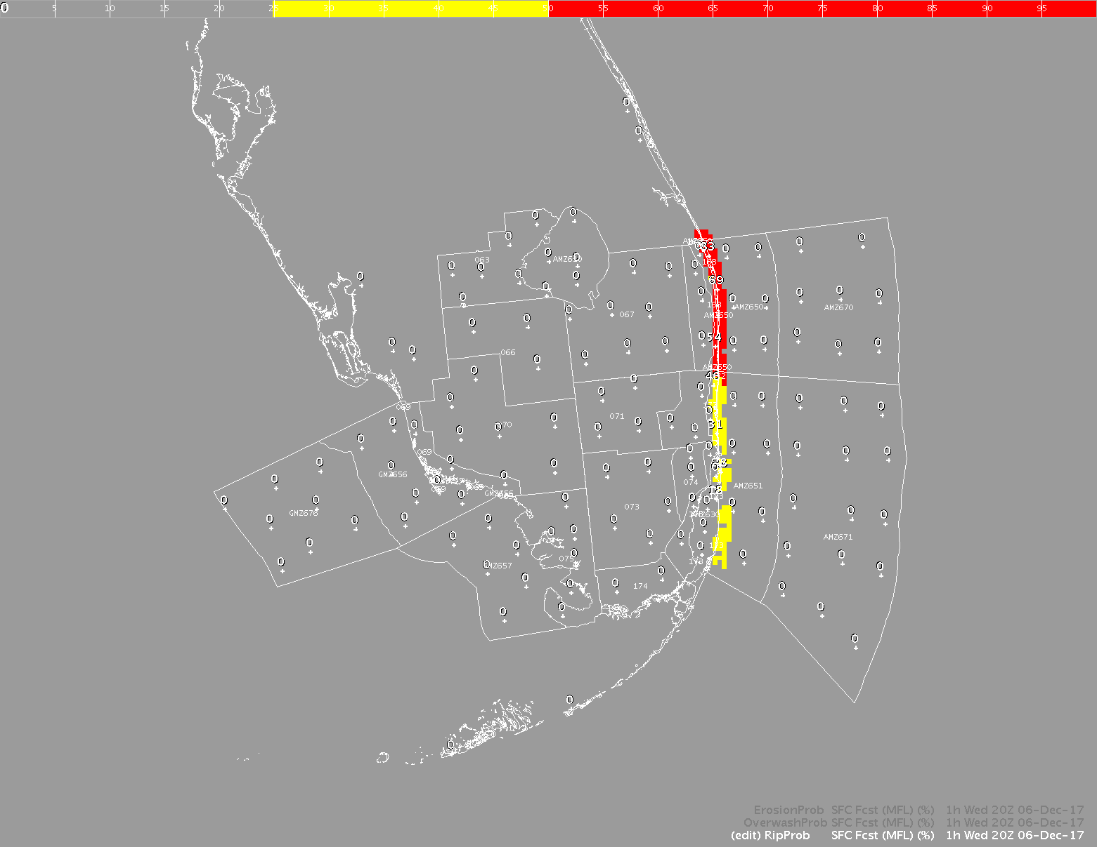

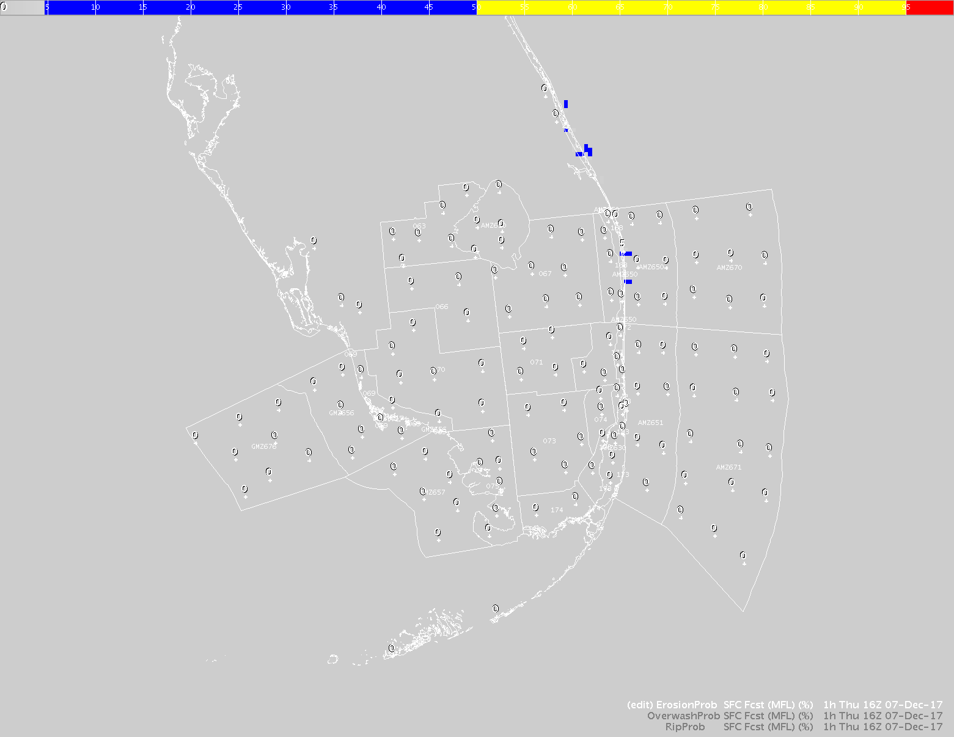

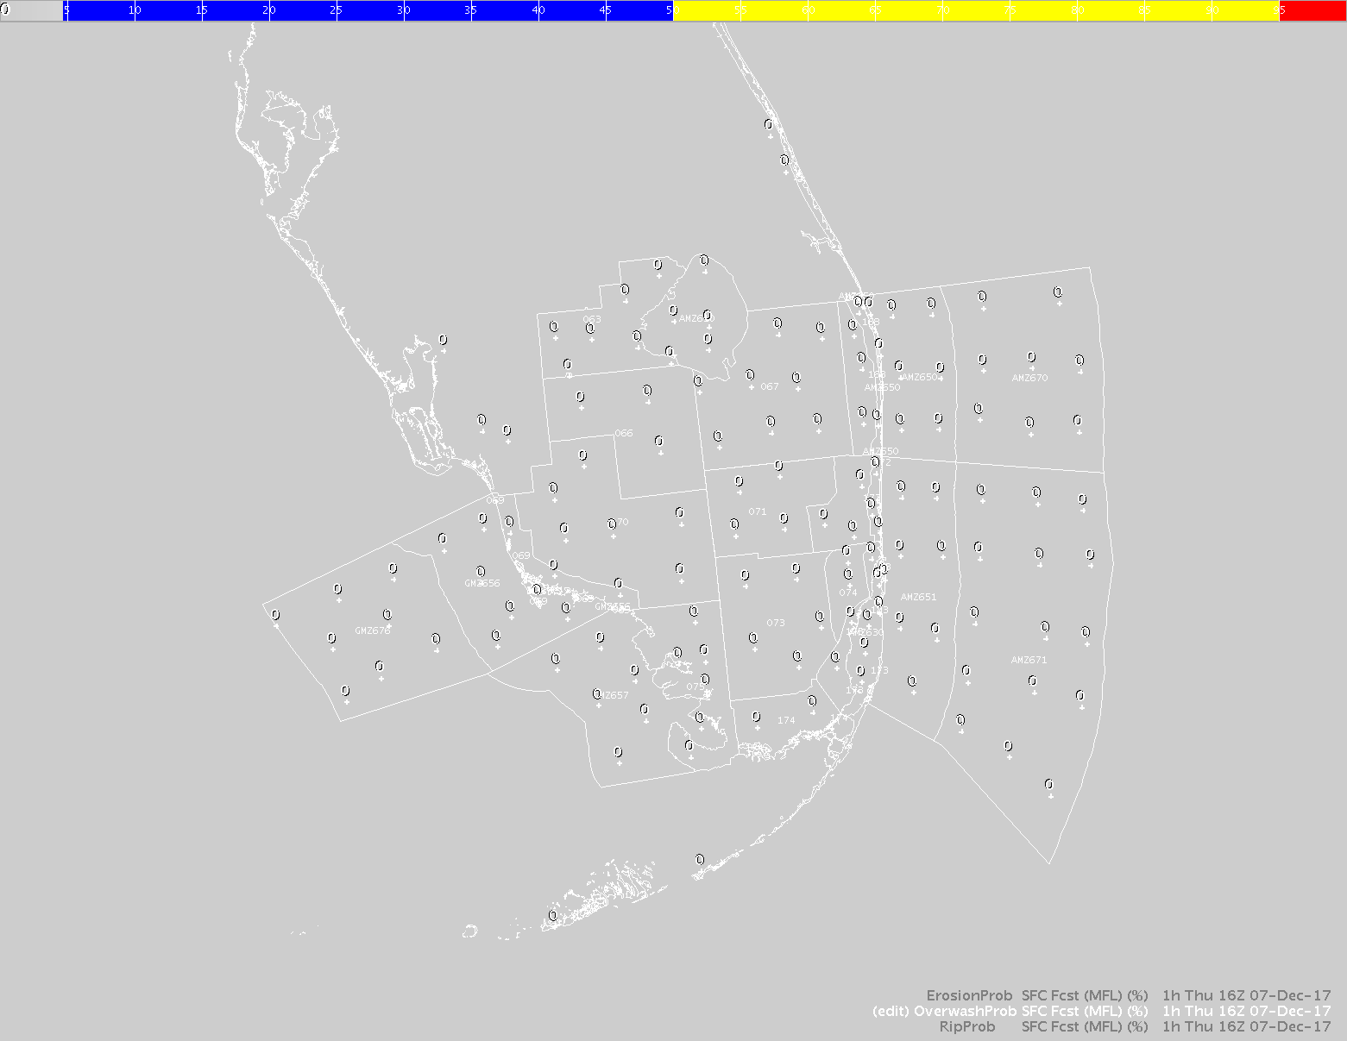

Appendix A: NWPSmessage script

Thanks to Paul Stanko from WFO Guam, scripts that would notify you with GFE banners when there are problems with NWPS runs at WCOSS are available. The scripts download the Forecaster warning files which WCOSS has been creating (The same ones behind NCO’s NWPS Model Status Page), then uses sendGfeMessage to turn them into AlertViz banners so the forecaster can see the warnings and take any action deemed appropriate. Following are the setup instructions (NOTE: Although these instructions are available here with the 18.1.1 docs, they can be installed at any time or with earlier AWIPS builds as well. Since these are ldad scripts they are not baselined. But they are being shared here for offices wanting to set them up):

- In px2f:/data/fxa/LDAD/data/LDADinfo.txt, add the following 2 lines:

# Feedback from NCEP regarding NWPS runs submitted to them
NWPSmessage | | | | | |preProcessNWPSmessage.sh |

2) Place the NWPSmessageLDADside.tgz tar archive in ls1:/ldad/bin/

3) Enter the command “tar -xzvf NWPSmessageLDADside.tgz”. This will create a directory /ldad/bin/NWPSmessage/ which contains 3 files, a shell script NWPSmessage.sh which should not need editing and 2 site configuration files, messages.urgent and messages.significant. The configuration files have instructions inline which will also be given in the next step.

4) Edit the configuration files if desired. Warnings listed in messages.urgent will be labelled as urgent in the log file and be displayed with a red AlertViz banner. Similarly, warnings listed in messages.significant will be labelled as significant in the log file and be displayed with a yellow AlertViz banner. Messages which do not appear in either file are treated as ignorable. If all warnings are ignorable (or there are no warnings), an entry will be made in the log labelled regular and a message will be sent to the AlertViz GFE status bar and no banner will appear. Only the last line of the file is actually read in, the rest is instructions and a list of possible warnings. The last line starts with either urgent or significant depending on which file, then a colon (:) then a space separated list of the warnings a site wishes to be in that category. Example… significant:exceeds hotfiles hotstart nests1 nests2 plot previous runlen timestep

5) Place the preProcessNWPSmessage.sh script in the directory px2f:/awips/ldad/bin/

6) Stop and start the LDAD processes on px2f to read in the new LDADinfo.txt file…
In the /awips/ldad/bin directory, type “./stopLDAD.sh” as user ldad. After this command completes, type the command “./startLDAD.csh”, again as user ldad.

7) With the infrastructure now in place, add or uncomment the following line at the end of the procedure Run_NWPS (You would have to create a site level version of the procedure):
os.system(‘ssh ldad@ls1 /ldad/bin/NWPSmessage/NWPSmessage.sh ‘+modelstarttime+’ ‘+GFEDomainname+’ &’)
There should be spaces between ssh & ldad, ls1 & /ldad, sh & ‘, ‘ & ‘ plus ‘ and &.
You should now be ready to receive any warnings WCOSS has for any of your NWPS runs.

